**Master Functional Document**

|  |  |
| --- | --- |
| **Application** | NGERP - Centra |
| **Service Bundle** | Master Management |
| **Service Request** | NTA Receipt |

**Description :**

NTA Receipt screen is used to make payment to the NTA AR Invoice.

**Workflow Process :**

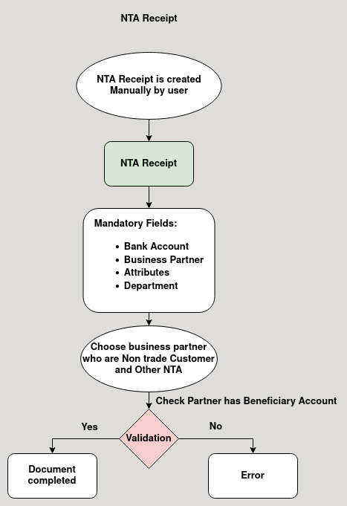

**Business Rules :**

* NTA Receipt is created in HQ only.
* It is manually created by the user in NTA Receipt Screen.
* User should give the mandatory field to complete the NTA Receipt:
  + Bank Account
  + Business Partner
  + Attributes
  + Department
* Payment amount should be greater than zero to show in NTA Receipt Allocation.
* Complete the payment to show in NTA Receipt Allocation.